Chapter 19, Problem 98.

A two-stage amplifier in Fig. 19.134 contains two identical stages with

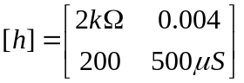

If Z_{L} = 20 kΩ, find the required value of V_{S} to produce V₌ 16 V.

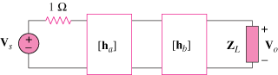

Figure 19.134
For Prob. 19.98.

